ifj.kke ctV
OUTCOME BUDGET
2007-08

laLd`fr ea=ky;
MINISTRY OF CULTURE

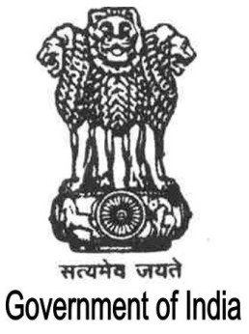
Hkkjr ljdkj
GOVERNMENT OF INDIA
Contents

Page No.

Executive Summary i - iii

Chapter I 1-12

Chapter II 13-158

Chapter III 159-164

Chapter IV-A 165-175

Chapter IV-B 176-245

Chapter V 246-257

Chapter VI 258-267

